**Seed And Nutrition Applier Agriculture Machine**

Irukulla Apoorva

[irukullaapoorva@gmail.com](mailto:irukullaapoorva@gmail.com)

B.vaishnavi

[bobbalavaishnavi11@gmail.com](mailto:bobbalavaishnavi11@gmail.com)

Bompelly Snehitha Rao

Anugam Saikiran

[saikirananugam@gmail.com](mailto:saikirananugam@gmail.com)

Poreddy SaiShiva Reddy

[saishivap01@gmail.com](mailto:saishivap01@gmail.com)

[snehitharaobompelly@gmail.com](mailto:snehitharaobompelly@gmail.com)

**Abstract:**

Farming is the backbone of Indian economy. In this agriculture sector, there is a lot of fieldwork, such as weeding, reaping, sowing etc. these operations previously were done by traditional equipment’s. Working with those equipment’s was tedious and laborious. Also traditional ways are time consuming. Mechanization in agriculture made farming easier and quick. There are variety of machines are available for almost every task in agriculture. Beginning with preparing land to the harvesting of crop and further process can be done by machines. This machines not only easier way to do this tasks but also very efficient. The agriculture machineries that are used now a days are costlier and cannot be afforded by most of farmer with rural background. Most of the farmers in India own very small pieces of land and owning this costlier machines may not be feasible for them. Apart from this most of farmers consider the traditional ways of farming as primary methods. Considering above mentioned factors there is need to develop such an equipment, which will be of multiple use and especially will be of low cost.

**Keywords: sowing, applying nutrition, disturbing soil**

**INTRODUCTION**

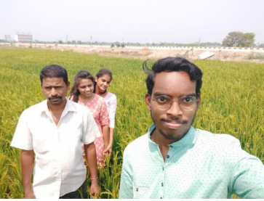

The concept of working with agriculture started with the identification of the problems faced by the farmers in the villages during farming. We have done a survey to find out what are the exact problems and what is the present situation of the farmer.

Place visited: Village :-Bheemaram

* We have visited around 4 farmers. On interacting with the farmers of Bheemaram we go to know the details of the work they do, and these are questions asked by us during the interaction:
* Do you have enough land to satisfy the needs of your family?
* Is there any lack of labour in your area? o What is the wage you will be giving for labour per day?
* Are in need of a good machionery(product) aside of good labour?
* Is this area in lack of electricity?
* What are the problems you are facing through electricty in farming?
* Is there any water shortage? What are the major work requirements you should do for growing the crops?
* What are the problems you will face cropping multiple crops?
* Is there any alternative source of income for farmers?
* How do you care for the crop for good yield?
* Will you face any lack of transparency in food production and distribution?

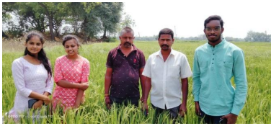

**PROBLEM STATEMENT**

The present agricultural equipment is of high cost. The rent of the machines is also considerably high. The machines are not easy to handle. The machines require a skill labour. The present machines are single purpose use. In early days, to perform any task of farming we required separate equipment for every different task. Here we are trying to make such an equipment that will perform a number of operations like sowing, ploughing, nutrition spraying etc.

**NEED STATEMENT**

To design and develop a suitable multipurpose equipment for ploughing, sow the seeds, and applying nutrition or manure that is used for farming to cultivate semiwet crops like maize, pulses , soya-beans.

**SYSTEM ARCHITECTURE:**

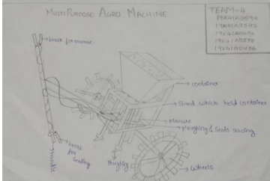

An Innovative multipurpose mechanism to overcome the problems by decreasing the man power and investment to sow seeds and apply nutrition. Farmers use to carry seeds manually with them, but our product help them to put the seeds in the container. Normally some farmers sow seeds and behind them other 4 farmers apply nutrition , but our product help them to do all these work by one member. This can done by break mechanisum. Our product help farmer to move easily, as it have chips to the wheel.

**Functional Decomposition**

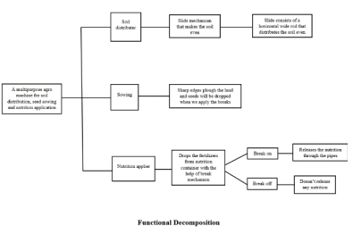

**Challenges faced and solutions**

* The user is worrying about the sowing of seeds and spraying the manure and ploughing the land at the same time.
* So our product is useful for all these activities and it is very useful for the farmers.
* Basically the user wants to save the time and the cost of labour and the user is spending most of the his expenditures on this specific segments.
* So undoubtedly, our product is going to save the time and money of the user and it is going to give the better output.

**IMPLEMENTATION AND WORKING:**

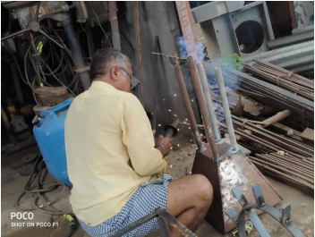

To fabricated our product, we used welding is a fabrication process that joins materials, usually metals using high heat to melt the parts together and allowing them to cool, causing fusion. Welding is distinct from lower temperature metal-joining techniques such as brazing and soldering, which do not melt the base metal.

**Soil distrubing :**

plough is attached to the machine and handle where user can handle to plough

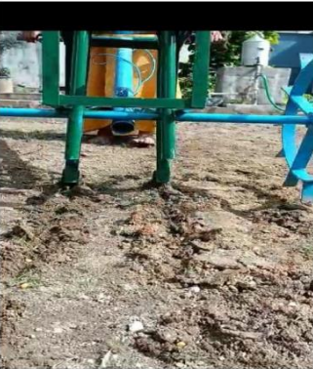

**Seed sowing:**

Sower is attached to plough and it is used using break mechanism attached to handle.

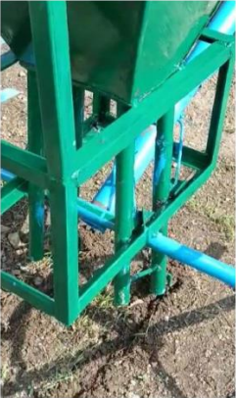

**Applying nutrition:**

Nutrition applier is behind the sower as it could be simultaneous process , it uses break mechanism

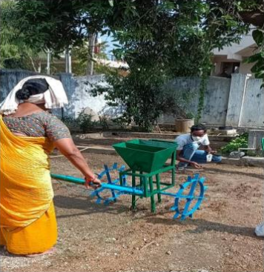

**Advantages**

* It can cover large field area in short time during spraying nutition
* The seed sowing is more effective and quick.
* Animal requirement can be eliminated.
* Less labor is required.
* It is advance and faster method of farming
* Simultaneous operations can be performed.
* Due to manual handling of machine crop

**MANAGEMENT PRACTICE FOR IRRIGATED MAIZE**

**Field preparation:** Field is ploughed to a depth of 25 to 30cm using mould board plough

**Spacing:** 60x25cm.

**Sowing:** Dibble the seeds at a depth of 4 cm and cover with soil. Put one/two seeds per hole.

**Time of application of fertilizers:**

100% P and K should be applied as basal. ‘N’ should be applied in 3 splits.

1. Ist peak 30-35 days (Knee high stage)
2. IInd peak 50-60 days (Tasselling)
3. IIIrd peak 70-80 days (Dough stage)

**Micronutrient:** ZnSo4: Apply ZnSo4 at 25 kg/ha at the time of sowing.

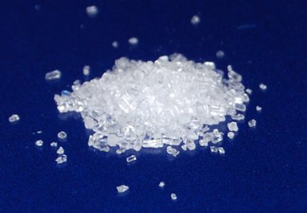

**Seed treatment**: Fungicide followed by Azospirillum (3 pockets)

**Average yield:** In the country, the average maize yield during 2019-20 was 1,973 kg per acre and in Telangana in the last five years yield of maize has been 2,600 kg per acre.

**Spacing:** Adopt a spacing of 45 cm between rows and 20 cm between plants in the row.

**EXPENSES IS CONSIDERED FOR 1 ACRE WITHOUT USING MULTI PURPOSE AGRO MACHINE**

**Expenses** **:**

* No.of labours for ploughing :**2**
* Amount paid to one farmer for

ploughing per day :**4000 – >(2*2000=4000)**

* No.of labours for sowing seeds :**4**
* Amount paid to one farmer

for sowing per day :**1600 – >(4*400=1600)**

* No.of labours for applying

nutrition/manure/fertilizer/seed treatment : **4**

* Amount paid to one farmer for applying per day:**1600 –>(4*400=1600)**
* No.of days to complete : **1 day**
* Cost of Nutrition : **4940 (4bags*1234=4940)**
* Cost of Fertilizer(DAP)/manure (25-30kg per acre): **1000**
* Cost of Maize seeds per 10kg(1 acre) : **3600**
* Cost of weeding : **1000**
* Cost of harvesting and shelling : **2000**
* Cost of transport : **1000**
* Cost of miscellaneous activities : **2500**

**Total** Expenses  **: 23240**

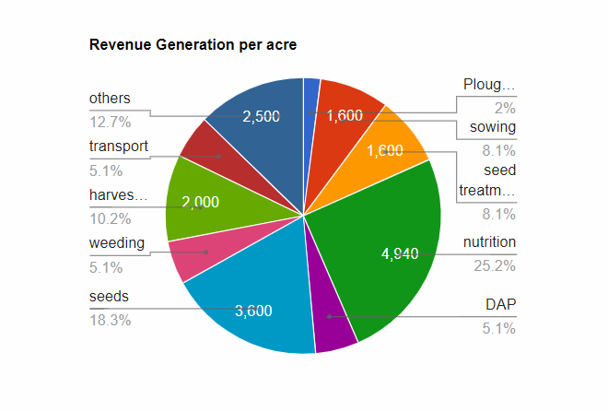

Total income from 1 acre maize cultivation = **45000**

Total cost incurred = **23240 per acre**

**Net income = 45000-23240**

**=21760 per acre**

**EXPENSES IS CONSIDERED FOR 1 ACRE WITH USING MACHINE**

**Expenses for first time using Multi Purpose Agro Machine:**

* Cost for machine :**15000**
* Nutrition/Fertilizer/manure cost :**4940**
* Fertilizer/manure cost (25-30kg per acre) :**1000**
* Maize seeds cost per 10kg(1 acre) :**3600**
* Cost of weeding :**1000**
* Cost of harvesting and shelling :**2000**
* Cost of transport :**1000**
* Cost of miscellaneous activities :**2500**

**Total Expenses**   **:31040 rupees**

Total income from 1 acre maize cultivation = **45000**

Total cost incurred = **31040 per acre**

**Net income = 45000-31040**

**=13960 per acre**

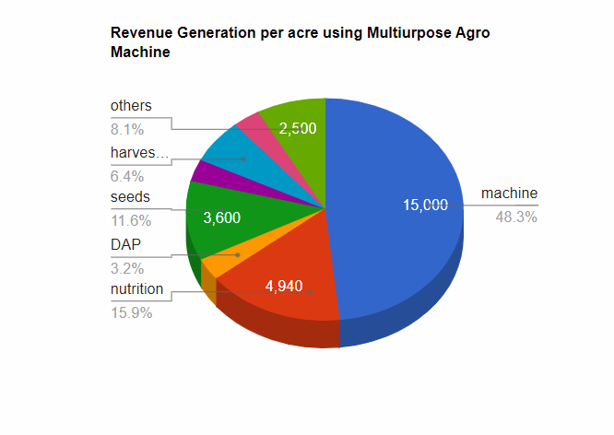

**EXPENSES THERE UPON USING MULTI PURPOSE AGRO MACHINE:**

* Nutrition/Fertilizer/manure cost :**4940**
* Fertilizer/manure cost (25-30kg per acre) :**1000**
* Maize seeds cost per 10kg(1 acre) :**3600**
* Cost of weeding :**1000**
* Cost of harvesting and shelling :**2000**
* Cost of transport :**1000**
* Cost of miscellaneous activities :**2500**

**Total Expenses :16040 rupees**

Total income from 1 acre maize cultivation = **45000**

Total cost incurred = **16040 per acre**

**Net income = 45000-16040**

**=28960 per acre**

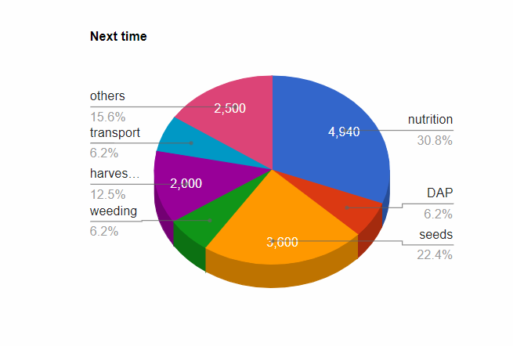

**DIFFERENCE BETWEEN NET INCOME PER ACRE**

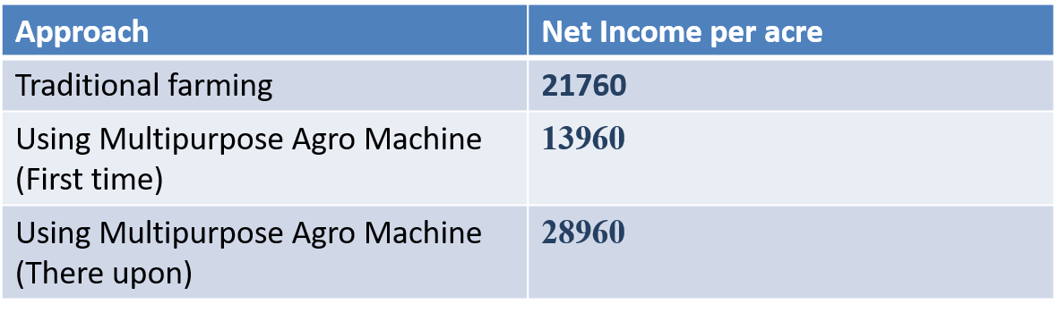

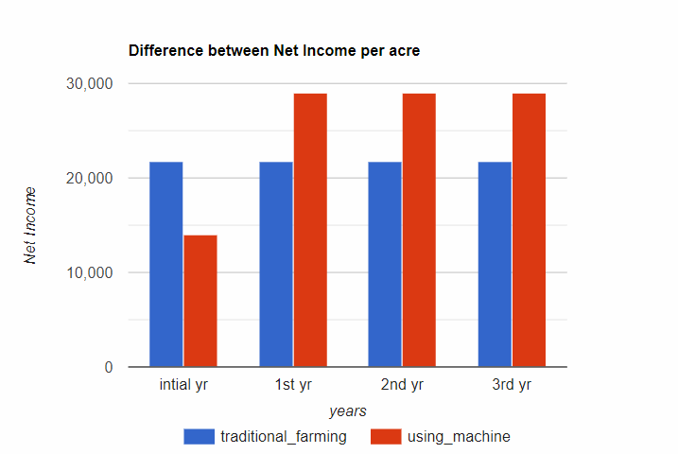

**BUDGET**

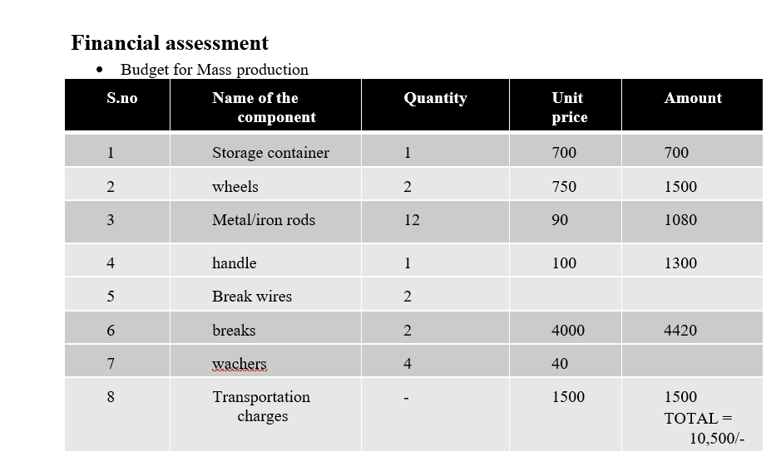

**CONCLUSION**

On the whole, we can say our product has many benefits, can be Ease-of handling, used for ploughing, sowing seeds, applying manure as well as it avoids the labours cost and scarcity of labour, even it is budget friendly and also reduces heavy time consumption. It’s a multi-purpose agro-machine for ploughing, sowing and fertilizing along with gripped tyres that are comfortably movable in soil.

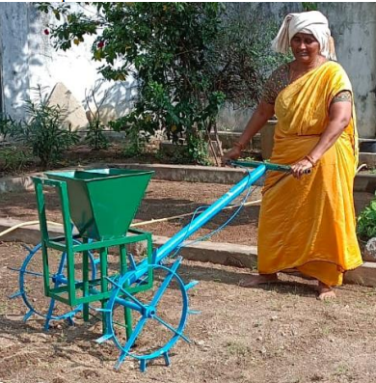

These results reducing the difficulty of the farmer. The farmers used to plough with tractor or using bullocks, sow the seeds by hard physical work. But our product reduced the difficulty by carrying the manure tank, seeds tank on wheels as well as four nozzles (two for carrying seeds and other two for manure) are kept to the tank for ploughing, sowing seeds and applying the manure and also it reduces the work load and time consumption. The user used to assign some labours for ploughing, sowing seeds and applying the manure in fields and said labour cost is very high these days. say a person does the three tasks of ploughing, sowing, and manure appliance, it takes very much time for completing the task. Let’s suppose three persons does three respective works, it takes less time but the labour cost will be huge.

But our product requires only one person for ploughing, sowing seeds and applying the manure and also it reduces the work load and time consumption as well as our product is ease of use, portable and durable with low cost. The user used to carry the seeds and fertilizers in the bags, but our product can carry them at a time and simultaneously the works are done. Finally, the farmers can be very satisfied by the profitable use of our product that helps them in a drastic way

